Decision Services

Setup Student Match/Merge Rules

and

Request a Student ID

Function Specifications

Approvals: |  | Name |  | Method and Location |  | Date |  | Version
Program Manager: |  |  |  |  |  | 1/7/04 |  | 1.3
Software Project Manager: |  |  |  |  |  | 1/6/04 |  | 1.3
Software Project Manager: |  |  |  |  |  |  |  | 1.3
SQA: |  |  |  |  |  | 1/9/04 |  | 1.3
MTS – independent tester |  |  |  |  |  | 1/9/04 |  | 1.3
Software Functional Manager: |  |  |  |  |  | 1/7/04 |  | 1.3
VP of MS SWD (Sponsor): |  |  |  |  |  | 1/9/04 |  | 1.3
Financial Analyst |  |  |  |  |  | 1/7/04 |  | 1.3

Change History Log

Date | Version | Change Description | Author
7/14/03 | 0.1 | Initial Draft
7/23/03 | 0.2 | Additional Draft using comments from A. Malik and D. Rodgers
7/28/03 | 0.3 | Additional Draft using comments from L. Tjaden and A. Malik
8/8/03 | 1.0 | Updated date of birth format to YYYYMMDD
10/28/03 | 1.1 | 1.2 added a bullet about the Adm Student ID being populated in dts-stu also added note about resolved students having an unsuccessful completion status in the workflow system.  2.1.1 grayed out notes about the staging database  2.2 grayed out mention of resolving methods - added note about resolution students file has unsuccessful status  FR 3.2.8.1 has been updated to gray out staging database  FR 3.2.11 added mention of the Adm Student ID  FR 3.2.12 added mention of the Adm Student ID  FR 3.2.13 noted students needing resolution during this phase will cause match to be unsuccessful and these records will be noted in the table with null PEM and Adm IDs
01/09/04 | 1.2 | Update Template to version 4.0
01/16/04 | 1.2 | Added Testing Identifier Creation Rules Functionality  Consisted of:  - Adding text to section 1.2 - Scope  - Adding 1 diagram to section 2.1.1 – System interfaces  - Adding text to section 2.1.2 – User interfaces  - Adding text to section 2.2 – Product Function  - Adding functional requirements to section 3.2.
01/16/04 | 1.2 | Brought other areas of this FS up-to-date  Consisted of:  - Removed 5 approval names  - Removing grey highlighting for functionality that will be implemented in this cycle.
2/17/04 | 1.2 | Updated to add “match students that have already completed the match step.
2/19/04 | 1.3 | Updated to 1.3, changed Sean on title page, removed Rich
07/23/04 | 1.4 | Added the Use Cases, Related Screens and Wire Frames for Setup Match/Merge Rule and Request Student ID
08/09/04 | 1.4 | Reworded Use Cases, Added a couple of Alternative Flows
Table of Contents

1.0 Introduction 4
1.1 Purpose 4
1.2 Scope 4
1.3 Definitions, acronyms, and abbreviations 5
1.4 References 5
1.5 Overview 5
2.0 Overall Description 5
2.1 Product Perspective 5
2.1.1 System Interfaces 5
2.1.1.1 Student ID Match/Merge 6
2.1.1.2 Generate Testing Identifier 7
2.1.2 Use Cases and Related Screens 8
2.1.2.1 Setup Student Match/Merge Rules 8
2.1.2.2 Request a Student ID 15
2.1.2.3 Displays for Error handling 26
2.1.3 Hardware Interfaces 27
2.1.4 Software Interfaces 27
2.1.5 Communication Interfaces 27
2.1.6 Memory Constraints 27
2.1.7 Operations 27
2.1.8 Site Adaptation Specifications 27
2.2 Product Functions 27
2.3 User Characteristics 28
2.4 Constraints 28
2.5 Assumptions and Dependencies 28
2.6 Apportioning of Requirements 28
3.0 Specific Requirements 28
3.1 External Interface Requirements 28
3.1.1 Inputs 28
3.1.2 Outputs 28
3.2 Functional Requirements 29
3.3 Performance Requirements 31
3.4 Software System Attributes 31
3.5 Other Requirements and Data Handling 32
4.0 Attachments 32
4.1 Appendix A – Reporting solutions- Student ID/Match/Merge Related Glossary 32

Introduction

Purpose
This document includes the functionality necessary to comply with the NCLB Act pertaining to student identification for longitudinal student reporting. Student identification includes assigning a unique PEM identifier to each student as well as providing a mechanism for matching students entering the Reporting solutions database to existing records within a customer. Included in matching will be a method to correct or merge student records to obtain more matches through resolution processes. Along with the PEM ID a State Student ID will be created that will be provided to customers. The customers will have input into the format of the State Student ID and will have the ability to define rules to apply to the State Student Ids that are created.

Scope
This functional spec will cover current deliverables as well as some future functionality. Future phase requirements are shaded in gray and currently out of scope. The Reporting solutions system will include the following for student processing:
- A unique Pearson Education Measurement (PEM) ID assigned to each student
- A matching process to identify if the student is new to the Reporting solutions system, pre-existing (matched), or a possible match (will need resolved)
- A student that is determined to be new will be assigned a new internal PEM ID and that ID will be updated on their record in the temporary database
- A student that is determined to be new will be assigned a State Student ID that will be made available to the customer. The customer will have input into the format of the State Student ID and any rules that should be applied to it during its creation.
- The customer will provide constant values (i.e. “VA” or “-“) that they want in their State Student ID.
- The customer will provide the position within the State Student ID that they want these constants to be placed.
- The customer will provide the beginning and ending value of the numeric sequence to be placed in their State Student ID.
- Character patterns that are not allowed to placed in the State Student ID will be provided by the customer.
- Future phase will provide the user a web interface to manage the State Student ID creation rules and formatting.
- A matching student will have their record in the temporary database updated using the existing id of the student
- A new student will have an n_adm_student_id assigned using the Adm Student ID sequence. This Adm Student ID will be used to update the n_adm_student_id in the DTS_STU table.
- A student that is a possible match will set the file status to needs resolution. The records that need resolved will be able to be selected out of the temporary system by selecting the records from the file attempting to be matched that do not have PEM ID or the Adm Student ID populated.
- The capability to use customer specific preferences for matching and resolution
- Customer preferences will be chosen and set up via an online process that will be documented in the Administrative Functional Specification listed in the references section and is out of scope for this Functional Specification
- The online resolution process for customers to merge students that were not matched nor added as new during the matching process will be documented in the Administrative Functional Specification listed in the references section and is currently out of scope for this Functional Specification. The functionality for student resolution will be part of later development.
- Reporting of matching criteria reliability will be added for future phases and will most likely be covered in the Administrative Functional Specification
- Future phase will add in additional student id retrieval for customers
- Customers will be able to request a student id for students they will be processing
- PEM will provide an encrypted version of the student id for the customer to use
- Process will involve matching, resolving and inserting the new student ids assigned in the Reporting solutions system
Future phase will add functionality to allow other groups in PEM to retrieve the PEM student ID for use internally at PEM

Definitions, acronyms, and abbreviations
Detail pertaining to definitions of student ID/Match/Merge terms can be found in the glossary in the Appendix of this document. Additional definitions, acronyms, and abbreviations can be found in the appendices of the General NCLB functional specification listed in the references.

References
Document | Author(s) | Progress
NCLB Solution CRAD |  | 2/2/04/2003
NCLB Solution General Requirements Functional Specifications |  | 10/28/2003
NCLB Solution – Administrative Services Functional Specification |  | 12/30/2003
NCLB Solution Configuration Setup Document |  | 12/04/2003  in progress

Overview
Refer to the Program Business Plan and the Program Synopsis (if applicable) for the Program overview.

Overall Description

Product Perspective

System Interfaces
The student id match/merge process will interface with other processes in the Reporting solutions system. The matching routine will occur when the data is in the temporary database prior to entering the staging and Admin database. The matching process will access data in the staging database and in the Admin database as well as doing a cross check on previous records read in the temporary database. There are no external interfaces for this phase. The data in the temporary database will be coming from the customer, however the student ID/matching/merging process will not interface directly with it. The users will be provided screens to use in the resolution process; the Administrative Services Functional Specification will document this.

Student ID Match/Merge
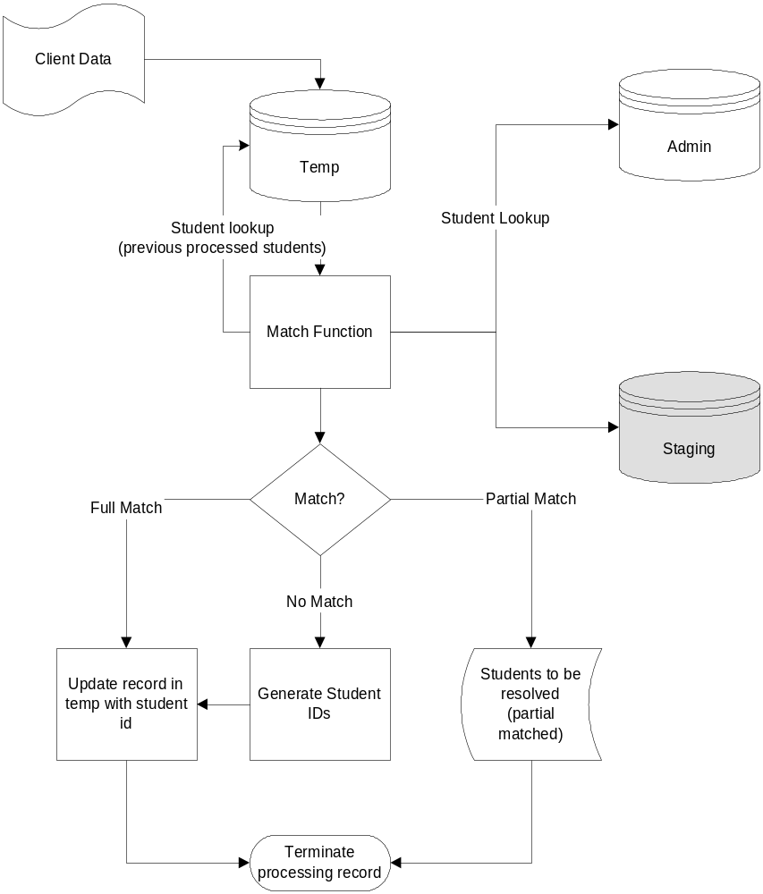

Generate Testing Identifier
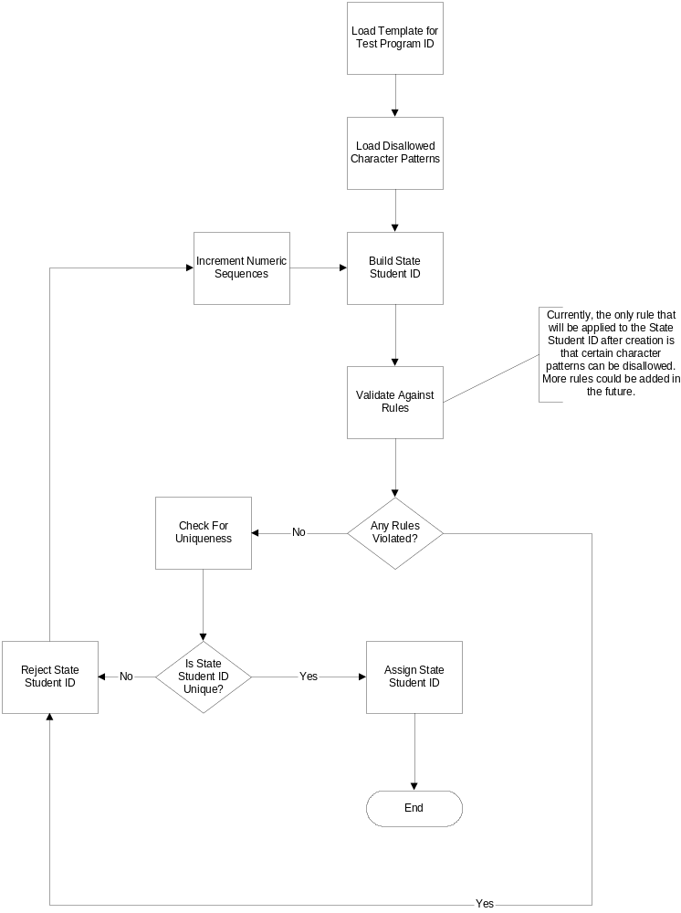

Use Cases and Related Screens

This section describes the use cases of the functional requirements for “Setup Student Match Rules” and “Request Student ID”. The related process chart, screen shorts, and screen wire frames are also presented.

Setup Student Match/Merge Rules

The “Setup Student Match Rules” process provides a web user interface for the user to setup customer specific match/merge rules. The match rules will be used to guide an automatic process to match /merge student IDs.

Process Chart

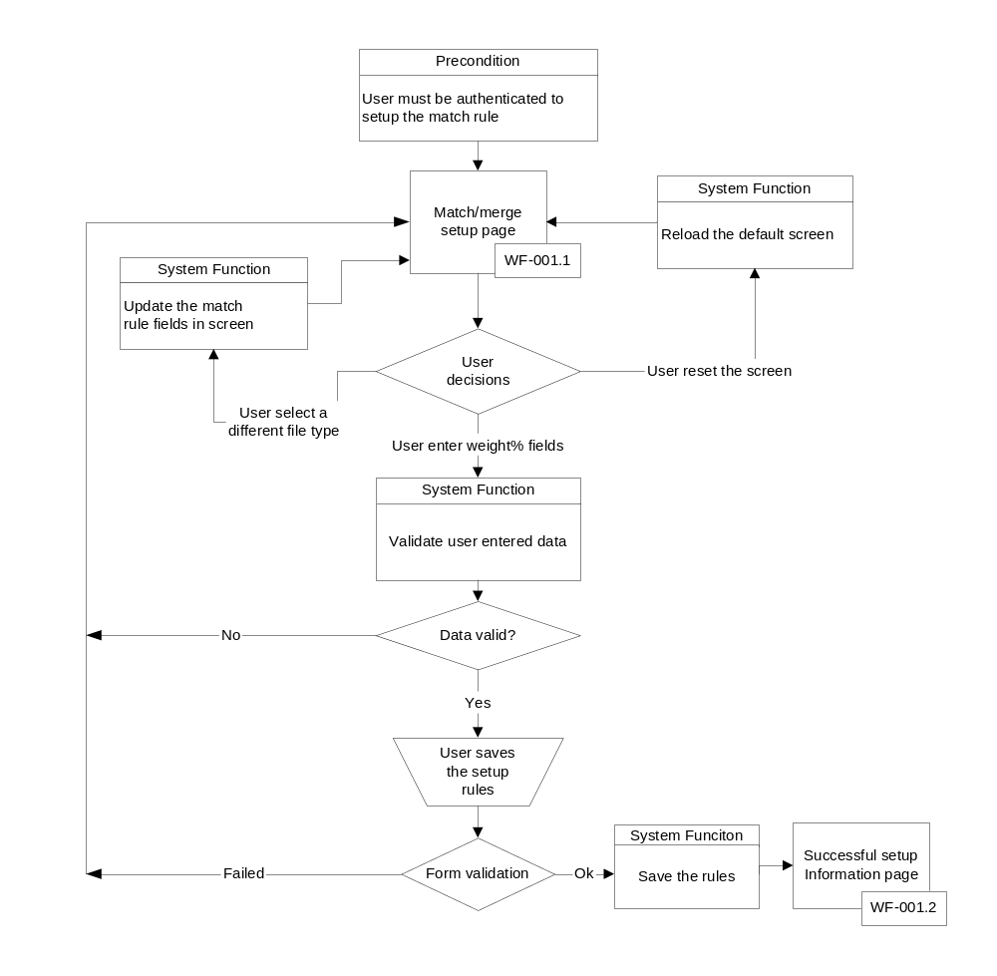

Use case UC-001

Use case name: Set up Match/Merge Rules
Level: User goal
Actor: Super administrator
Pre-condition:
User logged in the reporting system and has been authorized to setup the rules
User completed the State Rules setup
Student file type(s) exist (file type determines the match rules)
Post-condition:
The match rules are saved as persistent data
Summary: The user will do an initial setup or modify an existing student ID match rules. The match rules will be saved as persistent data and used to guide an automatic process of matching student ids.

Main Flow: Set up the match rules
# | User Action | System Response
1 | Requests view/edit match rules. | System returns a list of params that are required to return the match rules (In this case, the param is isolated to the file type for which the user wants to see the match rules).
2 | Selects a file type to edit/view its match/merge rules. | Returns the “match/merge setup” rules with the predefined match fields and pre-existing values.  The match fields are returned in a predefined order.  The match/merge rules may be different for different customers.
3 | Edits the weight % of match fields, the maximum resolution threshold and the minimum resolution threshold.  (Alternative #3, #5) | Based on the weight%s entered, computes the total weight.
4 | Saves the edited work.  (Alternative #4) | Saves:  - The previous values of match rules for a backup.  - The new match rules.  - A log history with the user name, the user role, and the time stamp associated with this setup.  - Informs the user that the match rules have been successfully saved and provides navigation guidance.

Alternative flow for #3: Entered weights break the match rules: 3a, or 3b, or 3c, or 3d, or 3e
# | User Action | System Response
3a | Enters a match field weight % which results in a total weight% exceeding 100%. | - Returns an error message warning that the total weight% ### entered violates the maximum 100% total weight% allowed.  - Does not update the total calculation field.  - Blanks the field.
3b | Enters an invalid match weight% value. | - Returns an error message,warning that invalid values were entered and a description of the valid values.  - Does not accept the invalid characters
3c | Enters an invalid maximum threshold (the valid value is between 0 to 100). | - Returns an error message,warning that invalid values were entered and a description of the valid values.  - Blank the field.
3d | Enters an invalid minimum threshold ( 0<= valid value < the maximum threshold -1). | - Returns an error message,warning that invalid values were entered and a description of the valid values.  - Blanks the field.
3e | Enters more than 10 weight% fields. | - Returns an error message,warning that the maximum allowed match rules is 10 and the user has entered 10 rules already.  - Blanks the last entered field.

Alternative flow for #4: Validation failure or leaving the page without saving: 4a or 4b
 | User Action | System Response
4a | Attempts to save the edited rules but less than three rules were defined | - Displays the error message warning that at least three match rules need to be defined
4b | Leaves the set up page without saving the page | Does not save any edited data

Alternative flow for #5: Remove a match rule
5a | Deletes weight% for a match rule | Clears the field
5b | Continue with Main flow #4

Screen Display – Match/Merge Setup

This screen allows the user to setup the Match/Merge rules which will be used as a set of control parameters for an automatic student ID match/Merge process. The match/merge rules could be different for different customers and different file types. The user will first select a file type to populate the related set of match/merge rule fields for editing. The following two screen shots display the screen layouts with or without a file type selection. The default entry screen is without a file type selection. After the user successfully saved the match rules, the information screen will be presented to the user. Values may be placed in fields for illustration purposes only and do not represent actual data.

Screen layout without a file type selection (default entry screen):

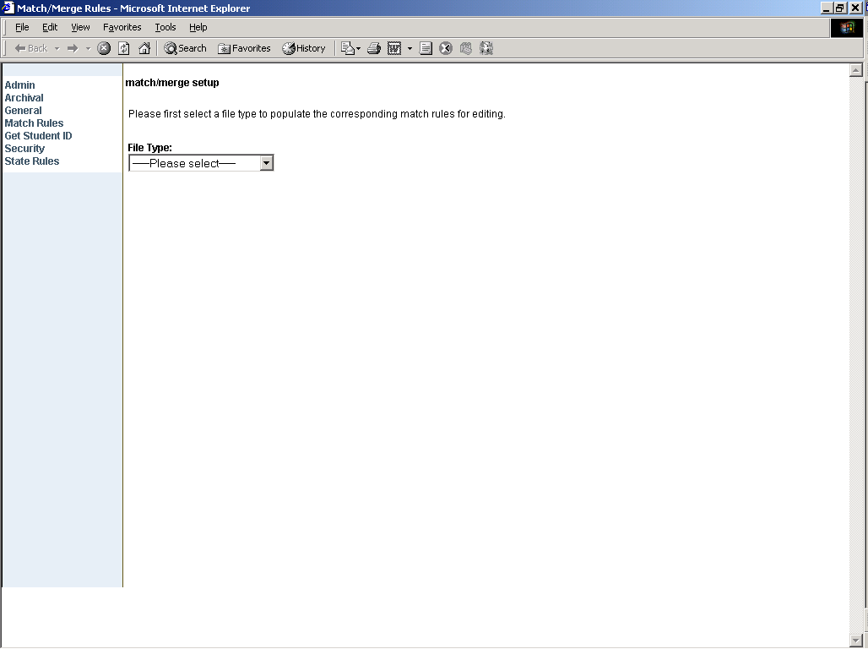

Screen layout with a file type selection:

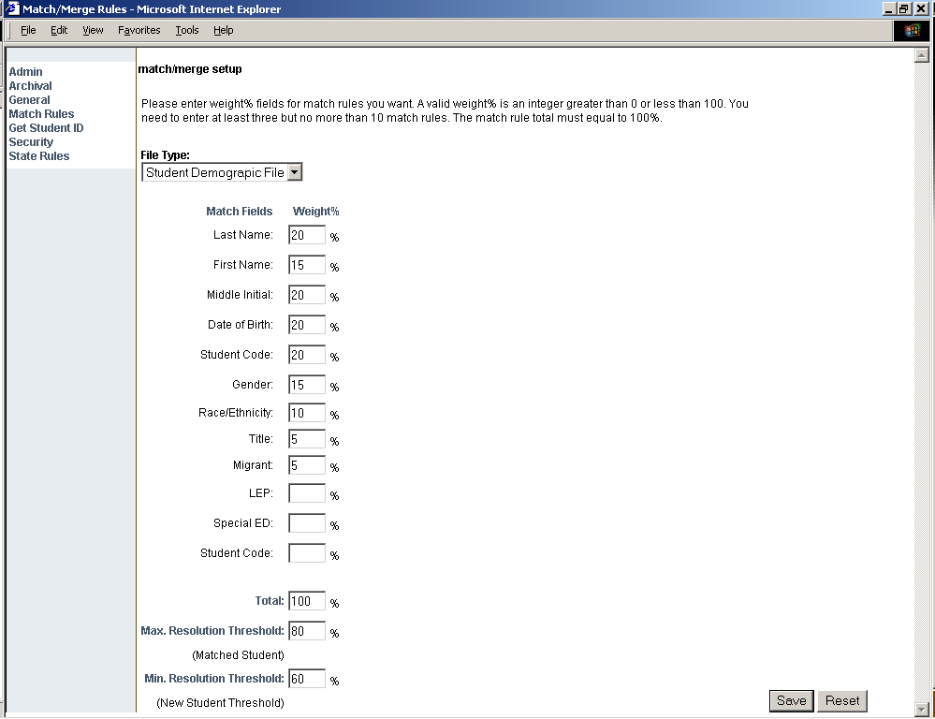

Wire frame WF-001.1

Field | Type* | Description | Rule(s)
Page title | DF | Displays the page title of “match/merge setup”
Page guide message | DF | Informs users how to use the page to set up the match rules. | The message will be different before and after a file type selection.
File type | DB | - Options of the different file types.  - Allows users to select the file type which decides the type of match rules.  - When user selects a different file type, the screen will be updated with the corresponding set of the match rule fields  - No match rule fields will be displayed if the file type is “---Please select---“ | - The default option is “-----Please select a file type----“  - The file type list will be sorted in a predefined order. (????? in_display_order or alphabetic order)  - The file types for Fall 2004 include: 1) student demographic files ; 2) student test files

The following fields will be populated when the user selects a file type:
Field | Type* | Description | Rule(s)
Match Fields | DF | A header to group the match fields labels
Weight% | DF | A header to group the match field text boxes
Match Field Names | DF | The name for a match field  There will be multiple match rule fields | Dynamic retrieved. Both the match rule names and the number of match fields are dynamically retrieved from the DB.
Weight% | TB | Text boxes for user to enter the match field weight%. | Valid values: integer 0 to 100.  It’s one to one relationship of a match field name and a weight% text box
Total | DF | Label of the total weight text field
Total | TB | The weight% sum accumulated from the weight% text boxes the user entered. It will be updated every time when the user enters a weight% | If the total weight the user entered exceeds 100, an error dialog box will be popped up informing the user the incorrect result total and the correct total should be
Existing Student Threshold | DF | Label
Existing Student Threshold | TB | A text box for users to enter a threshold which is used in the post student ID match process to match students. If the match process results the match percent equal to or bigger than this threshold, the match process happens. | Valid values: integer 1 to 100  Require field
New Student Threshold | DF | Label
New Student Threshold | TB | A text box for users to enter a threshold which is used in the post student ID match process to create new students. If the match process results a match percent lower that the Existing Student Threshold but higher than this new student threshold, a new student will be created | Valid value: integer 1 to 100 and less than the Existing Student Threshold  Required field
Reset | BT | Reload the last saved data
Save | BT | Save the rules | - At least 3 match fields have weight% entered  - At most10 match fields have weight % entered  - Total weight must equal to 100%  - Existing Student Threshold and new Student Threshold must have valid values

Types are: TB = Single-line text box, MLTB = Multi-line text box, RB = Radio button, DF = Display field (not editable), LB = list box, TREE = Tree structure, CB = Check box, DB = Drop-Down box, UP = Upload file, BT = Button

Information Screen for match rule setup completion

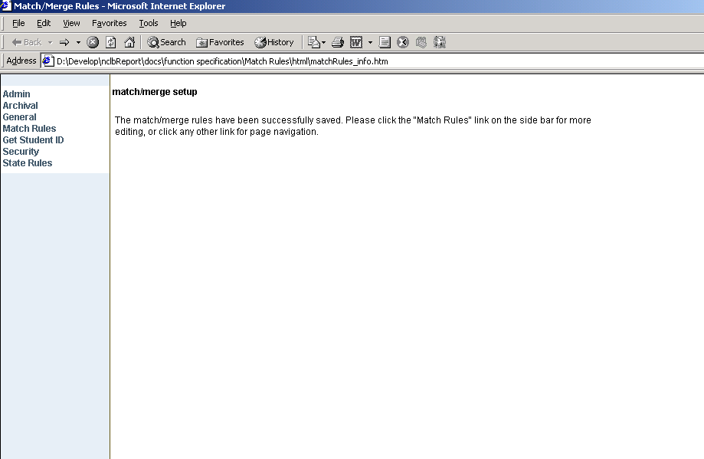

Wire Frame WF-001.2

Field | Type* | Description | Rule(s)
Page title | DF | Displays the page title of “match/merge setup”
Page guide message. | DF | The message: “The match/merge rules have been successfully saved. Please click the "Match Rules" link on the side bar for more editing, or click any other link for page navigation.”

Request a Student ID

The “Request a Student ID” process provides a web user interface for the user to request a student ID.

Process Flow Chart

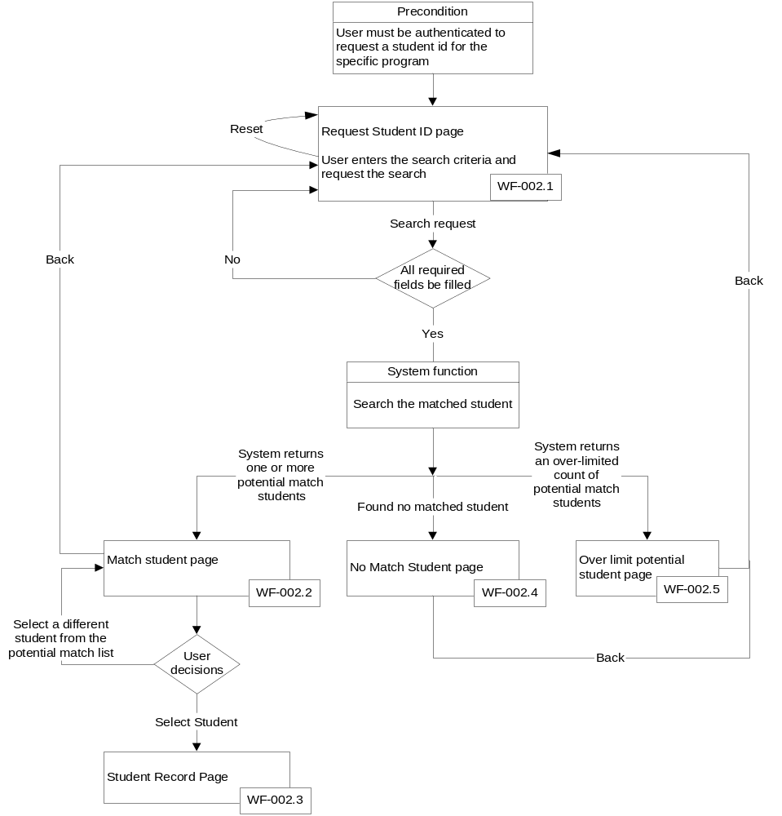

Use Case UC-002

Use case name: Request a Student ID
Level: User goal
Actor: Super administrator
Precondition:
User logged in the reporting system and has been authorized to request a Student ID.
Student demographic files have been loaded into the system.
Post-condition: The system found the requested Student ID.
Summary: The User enters the match criteria to get a Student ID and the system returns a list of potential Student matches. The User selects a Student from the potential match list and views the Student ID associated with the selection.

Main Flow: Find matched student
# | User Action | System Response
1 | Requests a Student ID | Returns set of search criteria for determining the potential student matches.
2 | User provides the district that the Student is associated with. | - Returns the search criteria maintaining the user selected values.  - Returns the subset of Schools that are associated with district.
3 | Submits search request  (Alternative flow:3a, or 3b, or 3c) | - Returns the potential match Student list sorted by the match scores. The Student with the highest score will be the first on the list.  - The Student with the highest score will be defaulted to be the potential match and the Student ID and other relevant information of this Student would be displayed as the potential match.
4 | Accepts the matched Student.  (Alternative flow:4a) | Returns the search criteria used as well the Student ID and other relevant information of the matched Student.
5 | Uses the Browser Print functionality and requests for the information to be printed. | Prints the search criteria and the matched Student information to the User’s Printer

Alternative Flow 3a: Find over-limited potential match students
# | User Action | System Response
3a. | Submits search request | Search results in an over-limit potential match student list count.  Displays an over-limit message:
3a.1 | Requests to refine the search criteria | Returns the search criteria maintaining the user selected values.
3a.2 | Continue with Main flow #3

Alternative Flow 3b: Find no match student
# | User Action | System Response
3b | Submits search request | No Students are found based on the search criteria. The System returns a message explaining that there were no matches found based on the search criteria.
3b.1 | Requests to refine the search criteria | Returns the search criteria maintaining the user selected values.
3b.2 | Continue with Main flow #3

Alternative Flow 3c: missing the required fields
# | User Action | System Response
3c | Submits search request without providing required information | Displays error message.
3c.1 | Requests to refine the search criteria | Returns the search criteria maintaining the User selected values.
3c.2 | Continue with Main flow #3

Alternative Flow 4a: Select Student from the Match List
# | User Action | System Response
4a | Selects a Student from the matched Student List. | The Student selected will be defaulted to be the potential match and the Student ID and other relevant information of this Student would be displayed as the potential match.
4a.1 | Continue with Main Flow #4

Screen Displays and Wire frames

Request a Student Identifier

This is the entry screen of the “Request a Student Identifier”. It allows the user to enter the search criteria to request a student ID. Values may be placed in fields for illustration purposes only and do not represent actual data.

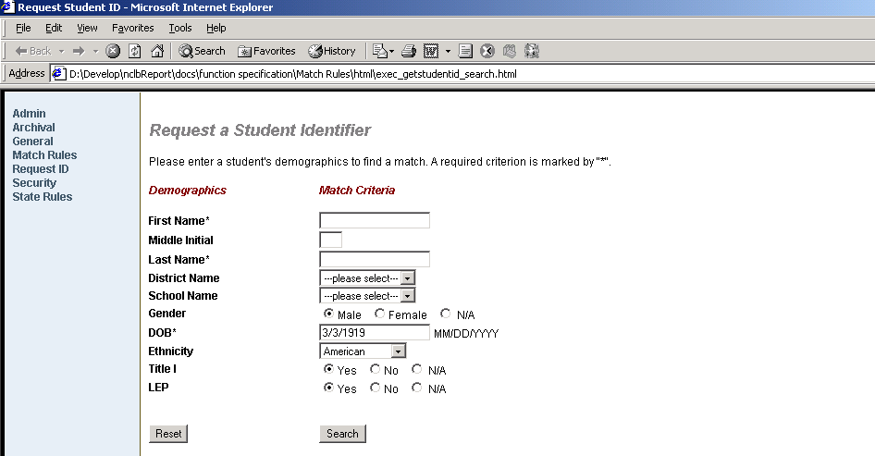

Wire Frame WF-002.1

Field | Type* | Description | Rule(s)
Page title | DF | The page title of “Request a Student Identifier”
Guide message | DF | Information of how to use the screen  ‘Please enter a student's demographics to find a match. A required field is marked by “*".’
Demographics | DF | A header label to group the demographics labels
Match Criteria | DF | A header label to group the match criterion input fields
First Name | DF | Label
First Name* | TB | To enter the last name criterion | - Max size is predefined  - Required field
Middle Initial | DF | Label
Middle Initial | TB | To enter the Middle Initial | Max size is predefined
Last Name* | DF | Label
Last Name | TB | To enter the Last Name | - Max size is predefined  - Required field
District Name | DF | Label
District | DB | - To select a district  - Selecting a district will populate the school name drop-down list | - Default value: “---please select---”  - Size = 1  - A single selection
School Name | DF | Label
School | DB | - To select a school  - The field is not visible before a district is selected | - default value:”---Please select---“  - Size =1  - A single selection
Gender | DF | Label
Gender | RB | to select a gender  Male, or Female or N/A | - Max size is predefined  - Default value:”Male”
DOB* | DF | Label
DOB | TB | to enter a date of birth | - Format: xx/xx/xxxx or x/x/xxxx
Ethnicity | DF | Label
Ethnicity | DB | An ethnicity list for user to select | - The default value: “American”  - A single selection
Title I | DF | Label
Title I | RB | to select Yes or No or N/A | The default value: “Yes”
LEP | DF | Label
LEP | RB | to select Yes or No or N/A | The default is “Yes”
Rest | BT | Reset all criterion fields to be blank or default
Search | BT | - Validate the required fields  - Submit the search request

Types are: TB = Single-line text box, MLTB = Multi-line text box, RB = Radio button, DF = Display field (not editable), LB = list box, TREE = Tree structure, CB = Check box, DB = Drop-Down box, UP = Uploadfile, BT = Button

Request a Student Identifier –Match Student

This screen is displayed after the user submitted the search request from the “Request a Student Identifier “screen (2.1.2.2.3.1) and the system returns one or more potential matched students (but less than a predefined limit). It allows the user to select the potential matched student as the requested student. The default potential match is the matched student with the highest match score (the system defined score). The user can also manually choose the potential match from a list of student demographics. Values may be placed in the fields for illustration purposes only and do not represent actual data.

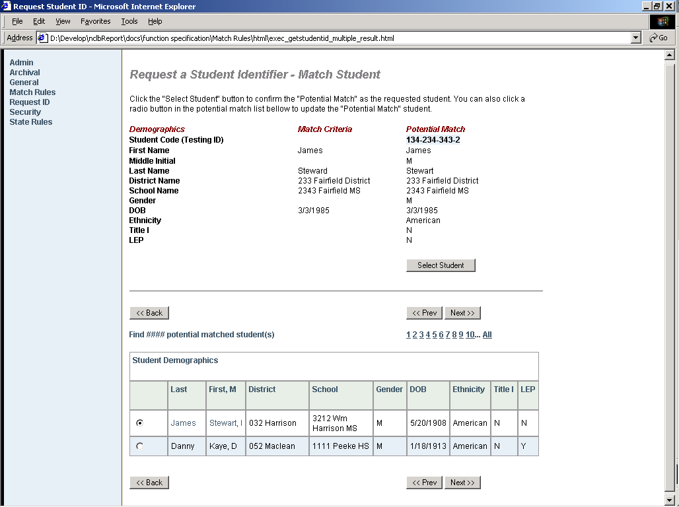

Wire Frame WF-002.2

Field | Type* | Description | Rule(s)
Page title | DF | Displays the page title of “Request a Student Identifier –Mach Student”
Guide Message | DF | Information on how to use the page
Demographics | DF | A header label to group the demographics labels
Demographic labels | DF | Labels to itemize each match criterion
Match criteria | DF | A header label to group search criteria
Match criteria | DF | Match criteria the user entered in the previous page
Potential Match | DF | Header label of the potential matched student record
Potential Match | DF | A set of the potential match student record
Select Student | BT | Clicking the button to confirm the potential match student as the request student and navigate the screen to the “Student Record” (section 2.1.2.2.3.3)
Student Demographics | DF | A list of potential matched student with the predefined number of columns. Each student in the list has a radio button associated with
Select a student | RB | A group of radio buttons. Clicking it to update the “Potential Match” student displayed on the top-right part of the screen
Back | BT | Clicking the button to go back to the search criteria screen. | The user previously entered search criteria remain
Previous | BT | Navigate to the previous page record of the list. | Not show on the first page
Next | BT | Navigate to the next page record of the list. | Not show on the last page
Found ### potential matched student(s) | DF | The count of the total matched students found. | “###” is a dynamic number
1,2,3,…All | Link | The link to jump to a record page directly without going through each page before or after the destination page | Only show when there are multiple pages

Types are: TB = Single-line text box, MLTB = Multi-line text box, RB = Radio button, DF = Display field (not editable), LB = list box, TREE = Tree structure, CB = Check box, DB = Drop-Down box, UP = Upload file, BT = Button

Request a Student Identifier – Student Record

This screen is displayed when the user select the potential match student from “Request a Student Identifier—Match Student” screen (2.1.2.2.3.2). Values may be placed in fields for illustration purposes only and do not represent actual data.

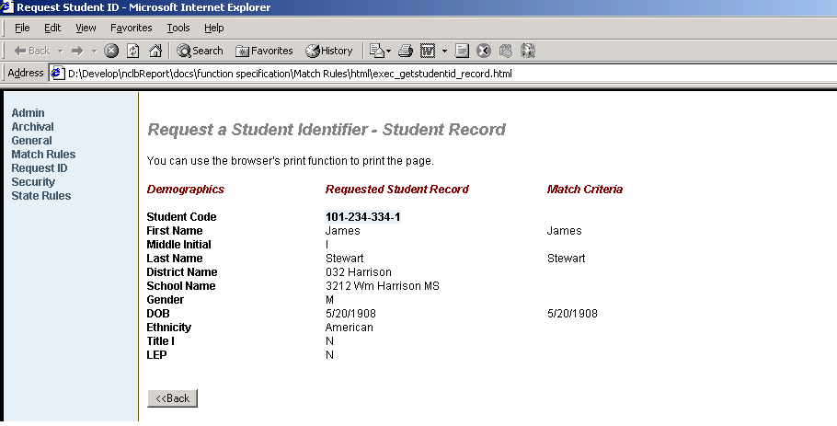

Wire Frame WF-002.3

Field | Type* | Description | Rule(s)
Page title | DF | Displays the page title of “Request a Student Identifier –Student Record”
Guide message. | DF | Information on how to use the page
Demographics | DF | A header label to group the demographic labels
Demographic field labels | DF | A set of labels for each demographic field
Requested Student Record | DF | A header label for the student record
Requested Student Record | DF | The Student information
Match Criteria | DF | A header label for the match criteria
Match Criteria | DF | A set of match criteria
Back | BT | Click the button to go back to the previous screen

Types are: TB = Single-line text box, MLTB = Multi-line text box, RB = Radio button, DF = Display field (not editable), LB = list box, TREE = Tree structure, CB = Check box, DB = Drop-Down box, UP = Uploadfile, BT = Button

Request a Student Identifier – No Matched Student

This screen is displayed when the user submits the search request from the “Request a Student Identifier “screen (2.1.2.2.3.1) and the system found no matched student. Values may be placed in fields for illustration purposes only and do not represent actual data.

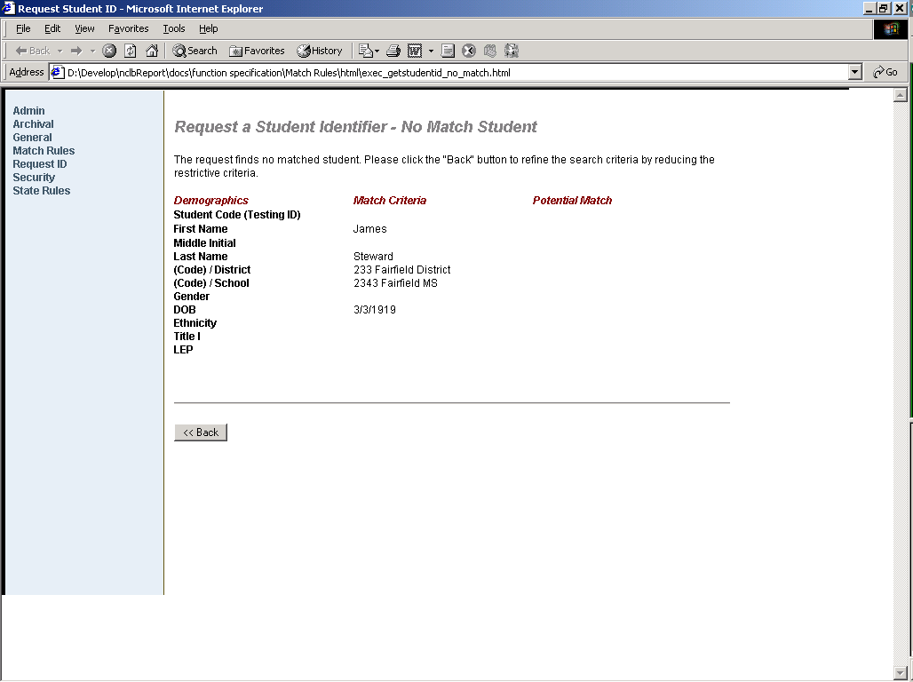

Wire Frame WF-002.4

Field | Type* | Description | Rule(s)
Page title | DF | Displays the page title of “Request a Student Identifier –Student Record”
Page message | DF | No found message:  “The request found no match student. Please go back to refine the search criteria by reducing the restrictive criteria.
Demographics | DF | A header label to group the demographics’ labels
Demographic item labels | DF | A set of label for each match criterion
Match criteria | DF | A head label to group the search criteria
Match criteria | DF | A set of match criteria the user entered in the search screen
Back | B | Clicking to go back to the previous search criterion screen. | The search criteria user entered remain on the search screen

Types are: TB = Single-line text box, MLTB = Multi-line text box, RB = Radio button, DF = Display field (not editable), LB = list box, TREE = Tree structure, CB = Check box, DB = Drop-Down box, UP = Upload file, B = Button, TB=table

Request a Student Identifier – Over Limit

This screen is displayed after the user submitted the search request from the “Request a Student Identifier “screen (2.1.2.2.3.1) and the system found over-limited match students. It reports the total number of records found and what the limit is. It also allows the user to go back to the search screen to refine the search criteria. Values may be placed in fields for illustration purposes only and do not represent actual data.

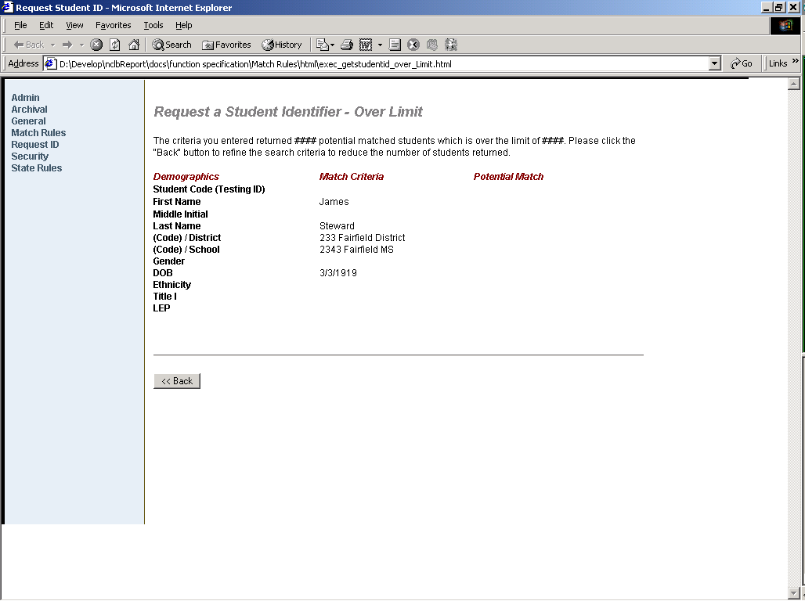

Wire Frame WF-002.5

Field | Type* | Description | Rule(s)
Page title | DF | Displays the page title of “Request a Student Identifier –Student Record”
Guide message. | DF | The message:  “The criteria you entered returned ### potential matched students which is over the limit of ###. Please click the “Back” button to refine the search criteria to reduce the number of students returned. | “###” are dynamic numbers
Demographics | DF | A header label groups the demographics labels
Demographic item labels | DF | A set of labels for each demographic field
Match criteria | DF | A header label of the criteria
Match criteria | DF | A set of search criteria the user entered
Back | B | Clicking the button to go back to the search screen. | The search criteria the user entered remain.

Types are: TB = Single-line text box, MLTB = Multi-line text box, RB = Radio button, DF = Display field (not editable), LB = list box, TREE = Tree structure, CB = Check box, DB = Drop-Down box, UP = Upload file, B = Button

Displays for Error handling
(Open for discussions)

Error will be displayed in three different ways according to the nature of errors and when it happens. The following describes the three scenarios.

Client site JavaScript dialogs

It is suggested that this category handles the error messages before the user submit the form. It is the way to validate user’s input as earlier as possible. The dialog will be a pop-up message.

Server site form validation

This is server site form validation and it happens when the user submits the form. If error detected, the error message will be displayed on the top of the screen.

System Exception

It currently follows the browser’s behavior for this category error display.

Hardware Interfaces
Refer to the NCLB Solution General Requirements Functional Specifications listed in the references section.

Software Interfaces
Refer to the NCLB Solution General Requirements Functional Specifications listed in the references section.

Communication Interfaces
The communication with the customer will be through the online match set up and match resolution process. The customer will be using the Internet to communicate their matching needs. The Administrative Services Functional Specification and the General Requirements Functional Specification listed in the references section will document this process in more detail.

Memory Constraints
Refer to the NCLB Solution General Requirements Functional Specifications listed in the references section.

Operations
Refer to the NCLB Solution General Requirements Functional Specifications listed in the references section.

Site Adaptation Specifications
Refer to the NCLB Solution General Requirements Functional Specifications listed in the references section.

Product Functions
The student id match/merge portion of the Reporting solutions product will process incoming student records and match them. The main functions are:
- Using the matching criteria and resolving methods selected by the customer to match incoming students to pre-existing students owned by the customer. These students must be within files that have already completed (successfully or unsuccessfully) the match step.
- Determining if a student is a new student, a match to an existing student or a partial match that needs to be resolved
- Updating the matched student records entering the system with the student id of the match found in the system
- Assigning new ids to students that do not previously exist in the Reporting solutions system and updating the record in the temp database with the new id assigned
- Creating testing ids that will be supplied to the customer and assigning them to students that do not previously exist in the Reporting solutions system and updating the record in the temp database with the new testing id assigned.
- Applying user defined templates and rules to the creation of testing identifiers.
- A web interface will be created to assist the users in creating testing id templates and rules.
- Noting partially matched students by assigning an unsuccessful status to the match step in workflow. Partially matched records will be noted because they will be without PEM id and admin student id in the temporary system (a different module will contain a resolution function which will be documented in the referenced Administrative Services Functional Specification – the file output is the solution currently chosen)
- Reporting on the match criteria used and resulting statistics from the match/merge process for the customer (this data can be used to determine the efficiency of the matching criteria and allow the customer to use this data for future improvements in their matching)
- Assigning and sending encrypted PEM student ID to customers for their use in tracking students. Sending the file will be the responsibility of another module.
- A different module to send student ID to other PEM groups (one PEM student ID) for their use in processing the student’s data

The match/merge process is a function required to support student longitudinal reporting. This will allow customers to track a student’s progress over the years. The process contains flexibility for each customer to adjust the way data is matched.

User Characteristics
Refer to the NCLB Solution General Requirements Functional Specifications listed in the references section.

Constraints
Refer to the NCLB Solution General Requirements Functional Specifications listed in the references section.

Assumptions and Dependencies
No assumptions were made due to inadequate requirements or unclear scope. This process is not dependent upon the design and development of another module or process.

Apportioning of Requirements
Anything shaded in gray is not a current requirement.

Specific Requirements

External Interface Requirements

Inputs
This in an internal process with no external inputs.

Input Name
Kind of data
Media
Sort Order
Frequency
Input Source

Outputs
This is an internal process with no external outputs.

Output Name
Kind of data
Media
Sort Order
Frequency
Output Destination

Functional Requirements

Note: These are only the specific CRAD requirements related to the student id/match/merge process. All other CRAD requirements are covered in the specific Functional Specifications.

Identifier | CRAD X-REF | Functional Requirement
3.2.1 | G-1, H-2, H-4, H-5, J-3, H-7 | The PEM ID will incorporate both logical elements as well as a number. The combination of the logical portion and the number will be a unique identifier for each student in the system.  - 1-8 date of birth (YYYYMMDD)  - 9-11 first 3 characters of the student’s legal first name.  - 12-15 a 4 digit number (0001 – 9999).  The process used to assign student ids will need to prevent assigning duplicate student identifiers.
3.2.2 | G-1, I-1, J-3 | Any one student will have a unique ID within a customer. All data related to the student will be found linked to the student ID. Test information, demographic information, school information will all be linked to the student and will be able to be looked up via ID. If a student moves from one customer’s control to another and both use the PEM Reporting solutions system, the student will have a unique id for each customer.
3.2.3 | G-1 | Students will only be matched within a customer test program id.
3.2.4 | H-5 | Crad requirement H-5 says, “The Reporting solutions student unique identifier must be unique throughout the entire system (across the nation).”  The identifiers will all be unique, however if a student moves from one customer to another that we process that student will have two different unique id numbers.
3.2.5 | H-3, H-4 | Future functionality will be to allow customers to request a student ID from PEM. This id will be an encrypted or hashed version of the unique student id used by PEM in the Reporting solutions system. Then PEM unique student ID will not be disclosed to the public.
3.2.6 | J-3 | The matching routine will use the logical part of the student id for the first round of matching against pre-existing students. Each customer must provide date of birth and student’s legal first name.
3.2.7 | J-3, J-1 | The following matching preferences (customer chosen) must be used in the match routine:  - Optional fields to use in the match process  - Weight assigned to each field for match  - Match Rate (Required percentage of matching data fields to declare a student match)  - New Student Rate (Required percentage of matching fields to declare a new student)  For example, a sample set of customer preferences could be:  - A match rate of 100%  - Optional match fields and weights of:  - Legal First name 35%  - Last Name 15%  - Gender 10%  - Date of Birth 30%  - Ethnicity 10%  - A new student rate of 30%
3.2.8 | H-6 | A customer’s Student ID will be an optional field for a customer to use in their matching process.
3.2.8.1 | J-3 | Matching routine will use data from the temporary system to compare/match against data in the staging system and in the admin system as well as against previously processed temporary records. These records must be from files that have already completed the match step.
3.2.9 | H-7, J-3, J-4 | First matching round will be done within matches of the logical id within the customer. When match(es) are found the routine will match against rest of the customer’s preferences. If perfect match is found then student is a match else matching routine will continue with match process of the additional criteria starting from scratch to determine if the student is new or a partial match.
3.2.10 | I-3, J-3, J-4 | The matching method will place incoming students in three different categories.  - Matched student  - New student  - Student to be resolved.
3.2.11 | J-3 | Matched students should have their record in the temporary database updated with the PEM student id and the Adm Student ID found in the system.
3.2.12 | J-3 | New Students should be assigned a unique student id, and an admin student id and these newly assigned ids should be added to their record in the temporary database.
3.2.13 | I-3 | Students needing resolution will be noted with null PEM and Admin IDs.
3.2.14 | J-1, J-2 | Future functionality will include a report of matching statistics related to the criteria chosen to give the customer an idea of how well their matching criteria is working.
3.2.15 | I-4 | The matching process initially will not use any verification processes.  Verification of varying degrees will be required of this system. If schools are matching using a 100% match rate and the data they use is confident enough no verification will be needed. If social security number is available the verification process will not be as important.  For future phases, a random population of students matched can be put on a report listing the information on the new file with the information previously existing in the system. This report can be sent to the customer for verification. If the customer finds mis-matches the matching criteria selected by the customer will need to be updated to prevent matching on the wrong students.  PEM should set up default values for matching. These values can be suggested to customers with a disclaimer to the customer stating if less than the suggested elements are used for matching inconsistent results could be expected.  NOTE:  Since the matching criteria are ultimately under the customer’s control the verification will be needed on a case-by-case basis. Once the customer has online access to their data, they should be able to select students to verify they have been merged correctly.  Another option for verification is reporting on those students matched that had a match rate of less than 100%. These students can be reported to the customer for their verification.  Reporting can also be done by having customers selecting criteria for verification. For example a customer can request a report of all students with the same name, date of birth, and gender. This report can then be validated to ensure the correct students have been merged and that no duplicates exist. This process could occur whenever the customer requested.
3.2.16 | I-2 | The database must be secured to only give access to the designated users and the users must have the appropriate privileges to the data they are viewing. The student data must be protected and anyone outside the company should not be able to access data out of their responsibility. Customers will only be able to access students under their control.
3.2.17 | H-2,H-3, H-7 | The users will have input in the format of their testing ids.
3.2.18 | H-2,H-3, H-7 | If the user creates a pre-defined template, they will create the template using zero-to-many constants and one numeric sequence.
3.2.19 | H-2,H-3, H-7 | The length of the testing identifier must be the same length for all testing identifiers created for a user.
3.2.20 | H-5 | For numeric sequences, the users will define a beginning and ending number. The length of the testing identifier will be determined by adding the length of all constant values plus the length of the ending number in the numeric sequence. Those numbers in the numeric sequence that are shorter than the ending number in the sequence will be left-padded with zeros.
3.2.21 | H-2,H-3, H-7 | Customers may define character patterns that are not allowed in their testing identifiers (i.e. 1111111,222222,3333333, etc.). Identifiers having these character patterns will be rejected.
3.2.22 | H-5 | All testing identifiers created must be unique within a testing program id. Any non-unique identifiers will be rejected.
3.2.23 | H-2,H-3,H-7, H-5 | Constants may be placed within a numeric sequence (e.g. 123-456-789). In this scenario, only one numeric sequence will be used.
* CRAD X-Ref is the cross-reference number back to the CRAD identifier number.

Performance Requirements
The performance requirements will vary depending upon what the customer chooses for its matching criteria. The design of the matching process using the assumed customer preferences will need to be as efficient as to match 1000 students a minute.

Software System Attributes
N/A

Other Requirements and Data Handling
N/A

Attachments

Appendix A – Reporting solutions- Student ID/Match/Merge Related Glossary
Customer – The school, district, or state entity that is the customer to the Reporting solutionssystem.

Duplicate – A student matches more than one student either as a partial match or full match using the matching criteria for a customer. They will need to be flagged for follow up by the customer.

Full Match – When an incoming student matches all of the matching criteria, the student is considered a full match.

Logical ID – The portion of the PEM unique student Id that will be generated from student data elements. The date of birth and the first three letters of the student’s legal first name will be the logical portion of the student id sometimes referred to as the logical id.

Match – The process to determine if a student entering the Reporting solutions system is new or existing in the current system. If the student matches an existing student in the Reporting solutions system with enough matching criteria to have a rate higher than the match rate a match is declared.

Matching Criteria – This is the data chosen for linking new students to existing students in the system. Different data elements such as date of birth, legal name, gender, ethnicity, birthplace, social security number, state id, parent’s names and any other data a customer decides to use to help identify a student can be used. The matching criteria will be used to look up potential matches in the Reporting solutions system by looking up students having the same data as the incoming student. The data chosen for matching can also be referred to as matching elements.

Match Rate – The percentage of matching criteria decided must be met for a student entering the system before a match is declared.

Match Weight – A percentage assigned to each matching element chosen by the customer. The weights assigned must add up to 100%.

Merge – The process used after a match has been found. The new data entering the system will be merged with the student match found in the Reporting solutions system. The student will not be assigned a new student ID, but instead will be connected to the match found. Merging will also occur during the resolution process. Possible matches will be paired and the customer will be able to decide if records are matches. If a match is found the records will be merged. Merging can include updating some student data already in the system if there is an error or updating data in the new record.

New Student Rate – A percentage of matching criteria the student entering the system must be at or below before the student is declared new and a new student ID is assigned.

Partial Match – When an incoming student matches some of the matching criteria, but not enough to be considered a match, the student is considered a partial match. Partial matches will need to go through the resolution process.

PEM ID - Pearson Education Measurement Identifier that is created during the match/merge process and provides a means to uniquely identify a student within the Reporting solutions system. The number of students records that need be queried in the match/merge process will aided by the fact that the PEM ID contains both the first 3 letters of the student’s last name and the student’s birth year.

Resolution - The process used to match and merge students not reaching the match rate and not below the new student rate.

State Student ID – Pearson creates the State Student ID during the match/merge process. The user has input into the format of the ID and any rules that should be applied to it. The State Student ID can be included in the match/merge input file to be used as matching criteria.

Student Longitudinal Reporting – An historical view of a student’s scores and progress over time.

Testing Identifier - The term that Virginia used for State Student ID.

Verification – A process to ensure the identifier assigned to a student is valid and correct. Valid means that the identifier is one actually included in the pool of identifiers to be assigned. Correct means that the identifier is accurately matched to the student.

